Consignment Testing Request Form
Contact Details
Name of Contact:
Affiliation of Contact:
Address:
Telephone (and FAX):
E-Mail:
Billing Address:
Project Title:

Details of the Testing Project (if necessary, please attach additional sheets or documents):

Transfer test results to third country or party? Yes / No |  |  |  | Intended for use in military/weaponry? Yes / No
The end application (if any of the above is “yes”, please also explain)
Preferred Date and Method of Meeting (in person or phone) |  |  | Preferred Date of Testing
Testing Fee Calculation: |  |  |  |  |  | For Office Use
Total: JPY
Comments: Facility Operator

Please complete this form – write inside of the thick-lined frame.
I have read, understood and agreed to abide by the terms and conditions for overseas organisations consignment testing, and confirm that the information I have given is correct. I request the consignment experiment be conducted at the Centre of Nanosatellite Testing at the Kyushu Institute of Technology, Japan.
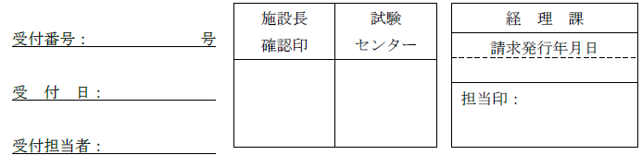
Signature:
For Office Use
Title and Name:
Affiliation:
Date (DD/MM/YYYY):
九州工業大学超小型衛星試験センター試験依頼書

